# ENTIDAD RELACIÓN

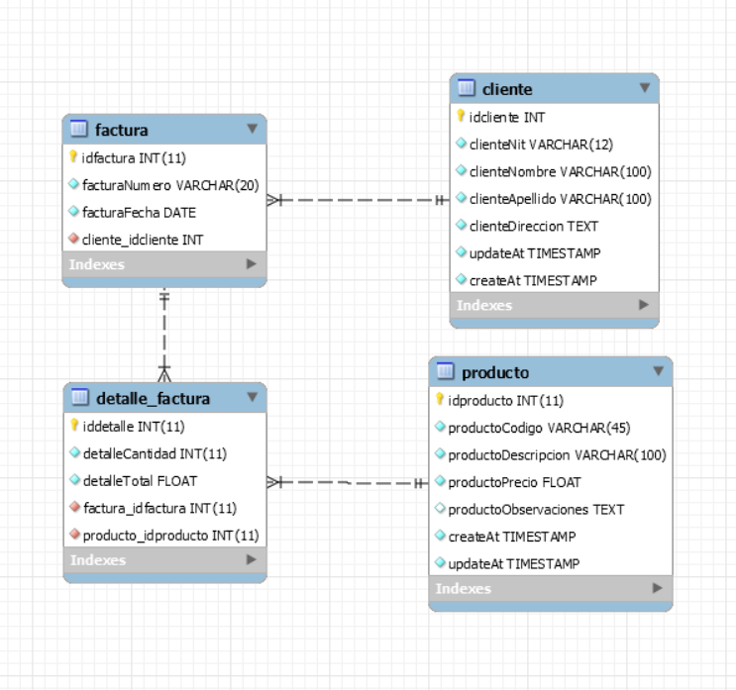

# SCRIPT BASE DE DATOS

-- MySQL Workbench Forward Engineering

SET @OLD_UNIQUE_CHECKS=@@UNIQUE_CHECKS, UNIQUE_CHECKS=0;

SET @OLD_FOREIGN_KEY_CHECKS=@@FOREIGN_KEY_CHECKS, FOREIGN_KEY_CHECKS=0;

SET @OLD_SQL_MODE=@@SQL_MODE, SQL_MODE='ONLY_FULL_GROUP_BY,STRICT_TRANS_TABLES,NO_ZERO_IN_DATE,NO_ZERO_DATE,ERROR_FOR_DIVISION_BY_ZERO,NO_ENGINE_SUBSTITUTION';

-- -----------------------------------------------------

-- Schema oe_factura

-- -----------------------------------------------------

DROP SCHEMA IF EXISTS `oe_factura` ;

-- -----------------------------------------------------

-- Schema oe_factura

-- -----------------------------------------------------

CREATE SCHEMA IF NOT EXISTS `oe_factura` DEFAULT CHARACTER SET utf8 ;

USE `oe_factura` ;

-- -----------------------------------------------------

-- Table `oe_factura`.`cliente`

-- -----------------------------------------------------

DROP TABLE IF EXISTS `oe_factura`.`cliente` ;

CREATE TABLE IF NOT EXISTS `oe_factura`.`cliente` (

`idcliente` INT NOT NULL AUTO_INCREMENT,

`clienteNit` VARCHAR(12) NOT NULL,

`clienteNombre` VARCHAR(100) NOT NULL,

`clienteApellido` VARCHAR(100) NOT NULL,

`clienteDireccion` TEXT NOT NULL,

`updateAt` TIMESTAMP NOT NULL DEFAULT CURRENT_TIMESTAMP,

`createAt` TIMESTAMP NOT NULL DEFAULT CURRENT_TIMESTAMP,

PRIMARY KEY (`idcliente`),

UNIQUE INDEX `clienteNit_UNIQUE` (`clienteNit` ASC) )

ENGINE = InnoDB;

-- -----------------------------------------------------

-- Table `oe_factura`.`factura`

-- -----------------------------------------------------

DROP TABLE IF EXISTS `oe_factura`.`factura` ;

CREATE TABLE IF NOT EXISTS `oe_factura`.`factura` (

`idfactura` INT(11) NOT NULL,

`facturaNumero` VARCHAR(20) NOT NULL,

`facturaFecha` DATE NOT NULL,

`cliente_idcliente` INT NOT NULL,

PRIMARY KEY (`idfactura`),

UNIQUE INDEX `compraNumero_UNIQUE` (`facturaNumero` ASC) ,

INDEX `fk_factura_cliente_idx` (`cliente_idcliente` ASC) ,

CONSTRAINT `fk_factura_cliente`

FOREIGN KEY (`cliente_idcliente`)

REFERENCES `oe_factura`.`cliente` (`idcliente`)

ON DELETE NO ACTION

ON UPDATE NO ACTION)

ENGINE = InnoDB

DEFAULT CHARACTER SET = utf8;

-- -----------------------------------------------------

-- Table `oe_factura`.`producto`

-- -----------------------------------------------------

DROP TABLE IF EXISTS `oe_factura`.`producto` ;

CREATE TABLE IF NOT EXISTS `oe_factura`.`producto` (

`idproducto` INT(11) NOT NULL AUTO_INCREMENT,

`productoCodigo` VARCHAR(45) NOT NULL,

`productoDescripcion` VARCHAR(100) NOT NULL,

`productoPrecio` FLOAT NOT NULL,

`productoObservaciones` TEXT NULL,

`createAt` TIMESTAMP NOT NULL DEFAULT CURRENT_TIMESTAMP,

`updateAt` TIMESTAMP NOT NULL DEFAULT CURRENT_TIMESTAMP,

PRIMARY KEY (`idproducto`),

UNIQUE INDEX `productoCodigo_UNIQUE` (`productoCodigo` ASC) )

ENGINE = InnoDB

DEFAULT CHARACTER SET = utf8;

-- -----------------------------------------------------

-- Table `oe_factura`.`detalle_factura`

-- -----------------------------------------------------

DROP TABLE IF EXISTS `oe_factura`.`detalle_factura` ;

CREATE TABLE IF NOT EXISTS `oe_factura`.`detalle_factura` (

`iddetalle` INT(11) NOT NULL AUTO_INCREMENT,

`detalleCantidad` INT(11) NOT NULL,

`detalleTotal` FLOAT NOT NULL,

`factura_idfactura` INT(11) NOT NULL,

`producto_idproducto` INT(11) NOT NULL,

PRIMARY KEY (`iddetalle`),

INDEX `fk_detalle_factura_factura1_idx` (`factura_idfactura` ASC) ,

INDEX `fk_detalle_factura_producto1_idx` (`producto_idproducto` ASC) ,

CONSTRAINT `fk_detalle_factura_factura1`

FOREIGN KEY (`factura_idfactura`)

REFERENCES `oe_factura`.`factura` (`idfactura`)

ON DELETE RESTRICT

ON UPDATE RESTRICT,

CONSTRAINT `fk_detalle_factura_producto1`

FOREIGN KEY (`producto_idproducto`)

REFERENCES `oe_factura`.`producto` (`idproducto`)

ON DELETE RESTRICT

ON UPDATE RESTRICT)

ENGINE = InnoDB

DEFAULT CHARACTER SET = utf8;

SET SQL_MODE=@OLD_SQL_MODE;

SET FOREIGN_KEY_CHECKS=@OLD_FOREIGN_KEY_CHECKS;

SET UNIQUE_CHECKS=@OLD_UNIQUE_CHECKS;